**Data Science & Business Analytics Tasks**

**Task #3 Exploratory Data Analysis - Retail**

**-By Rana Rajeshvari**

Perform ‘Exploratory Data Analysis’ on dataset ‘SampleSuperstore’

Dataset: <https://bit.ly/3i4rbWl>

Profit of Cities

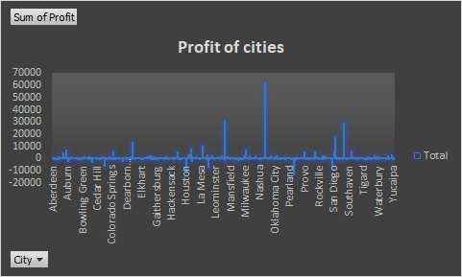

Nashua city is the highest profit gainer from the analysis and  As a manager, I should be a focus on the Southaven, Leominster, San Diego cities those cities are profitable so we focus on that and try to increase profitability. Some of the cities like Auburn, Cedar Hill, Pearland have loess so we try to increase their sales and make it profitable.

**Sales of Cities**

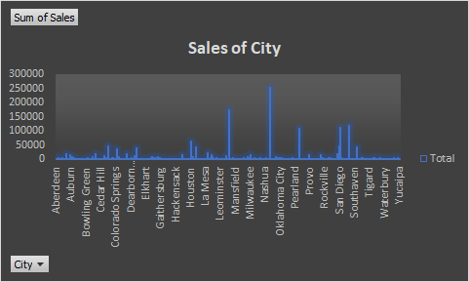

In the analysis, there are some cities who more focus on Sales they are good at sales but do focus and increase some change of marketing strategies and increase the sales of the Cities like as per the culture, customer base, etc.,

**Sales of state**

The highest Sales of the state is California, New York, Virginia have the highest Sales state

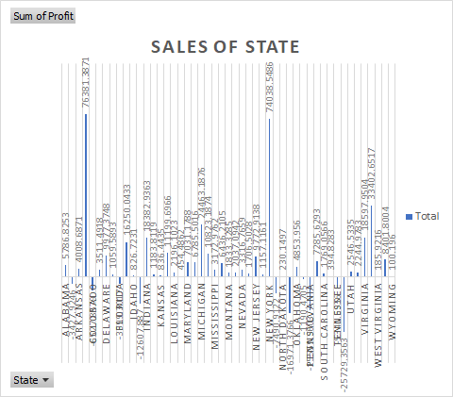

**Profit and Sales Value**

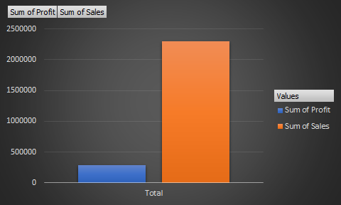

Profit and the sales are shown in the above chart, we can analyze that above 2000000 Sales Profit is less than 500000

**Profit & Sales of Category**

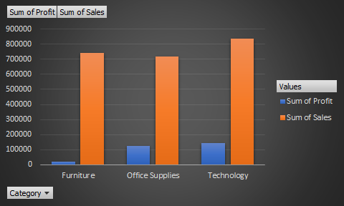

Superstore gets a high profit and sales in the Technology category. Furniture has higher sales and Office Supplies have a higher profit than furniture.

**Sub-Category Sales and profit**

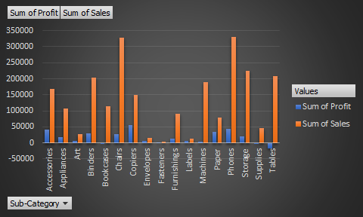

Sub-Category-wise Copiers give the highest profit and Phones give the highest Sales.

**Pivot Table**

